Native Dynamic SQL DELETE:

CREATE TABLE DEPARTMENTNAMES(

depid int PRIMARY KEY,

depname varchar(64)

);

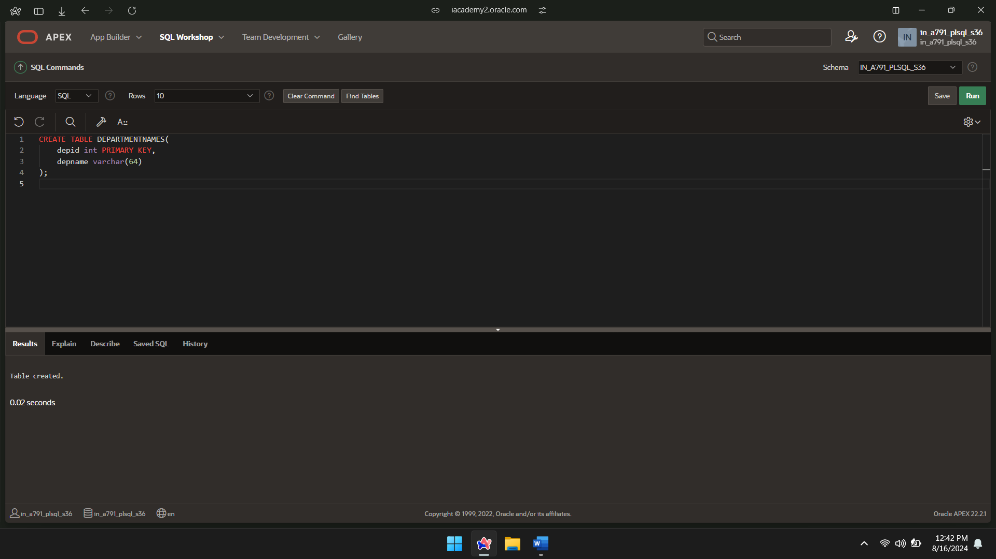

INSERT INTO DEPARTMENTNAMES VALUES (100,'FINANCE');

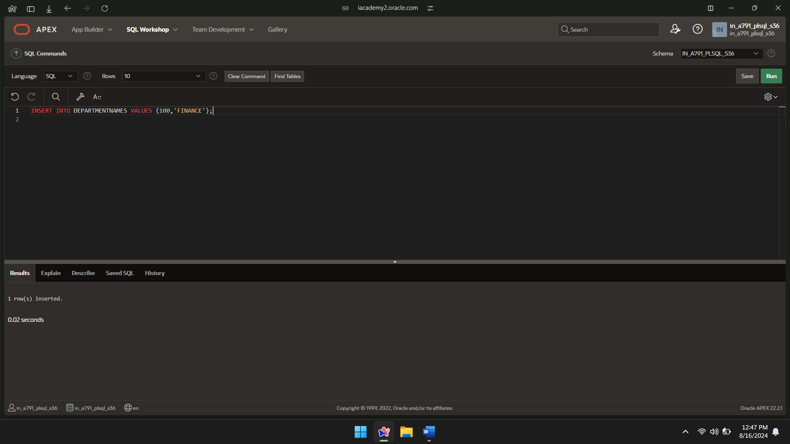

INSERT INTO DEPARTMENTNAMES VALUES (101,'MARKETING');

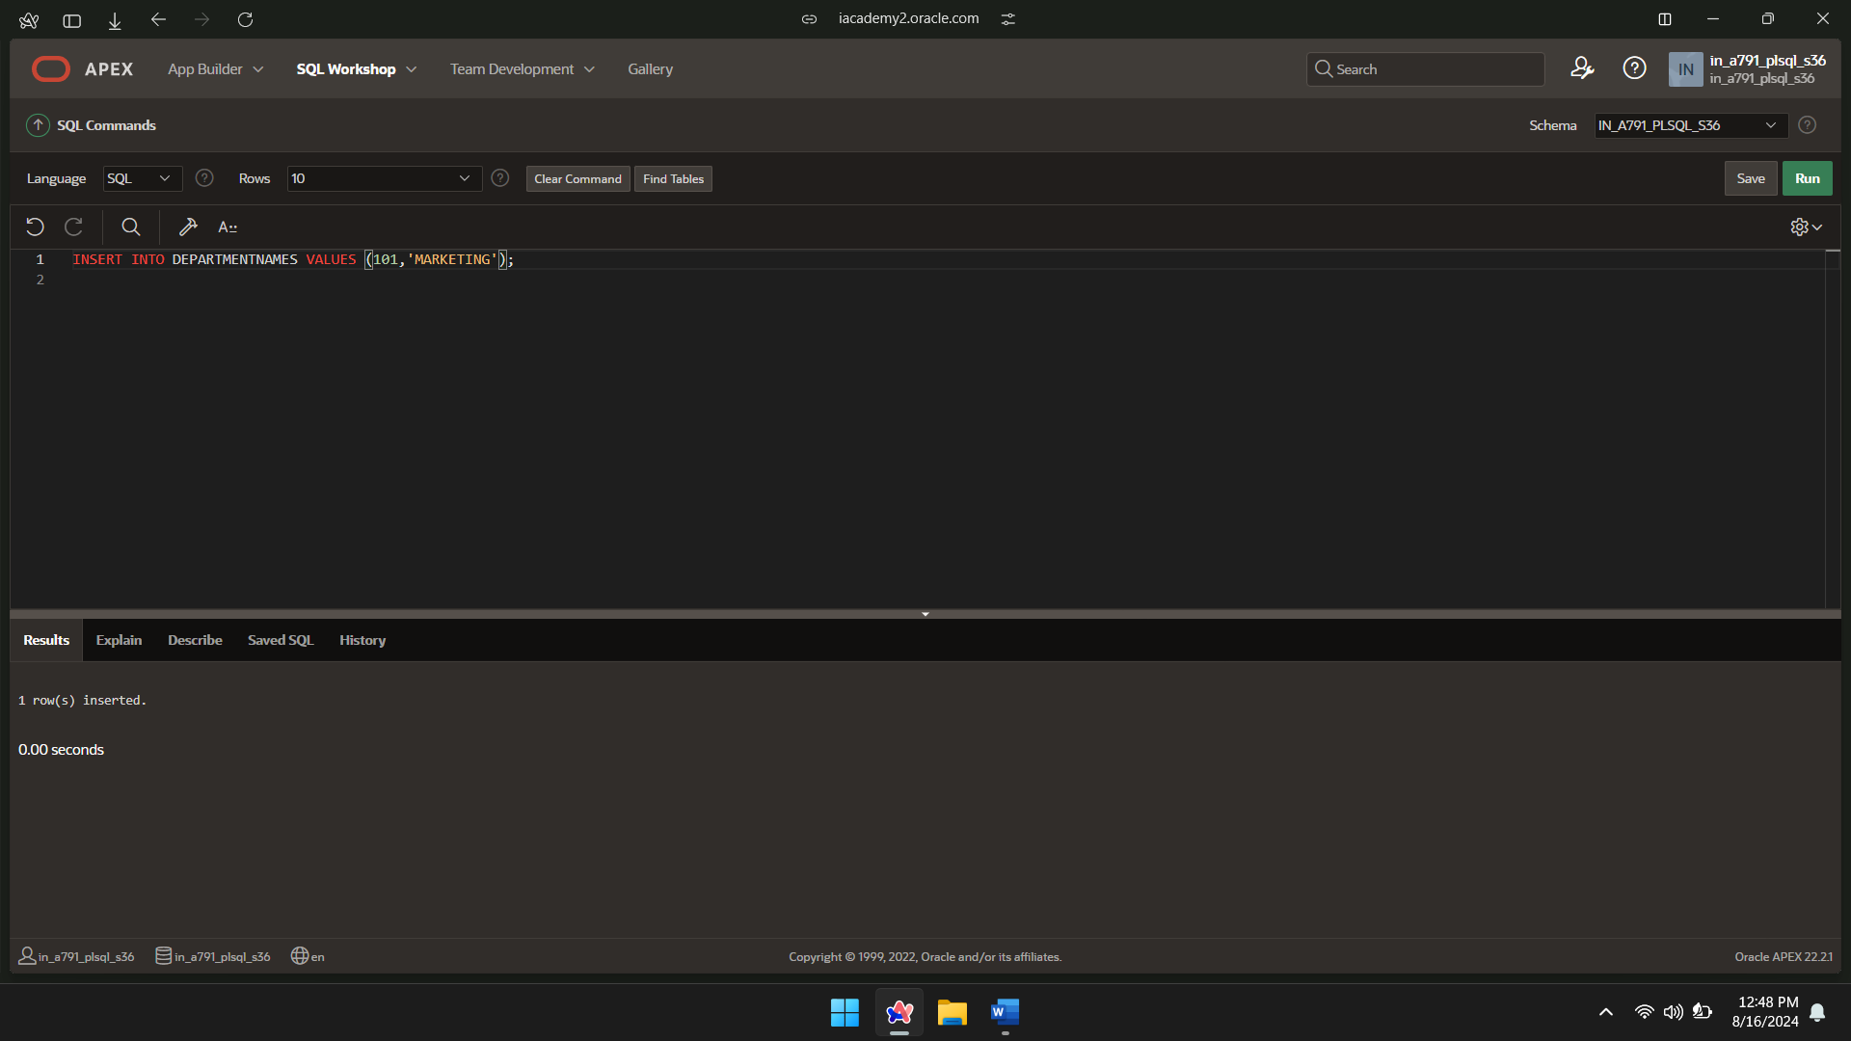

INSERT INTO DEPARTMENTNAMES VALUES (102,'SALES');

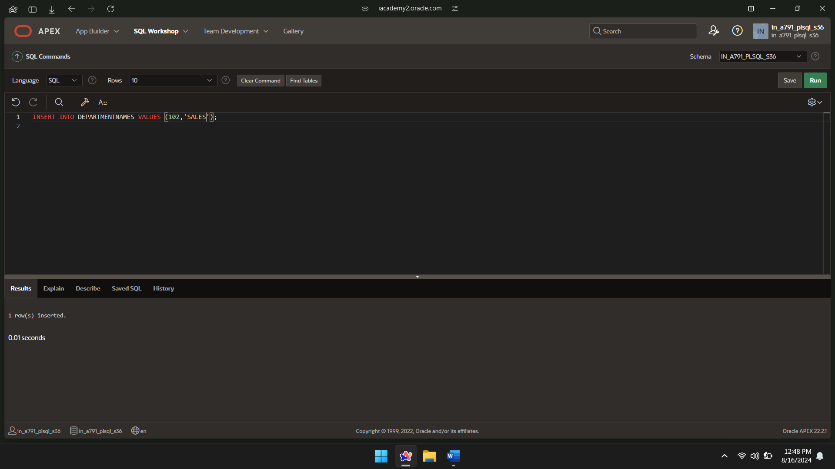

SELECT*FROM DEPARTMENTNAMES;

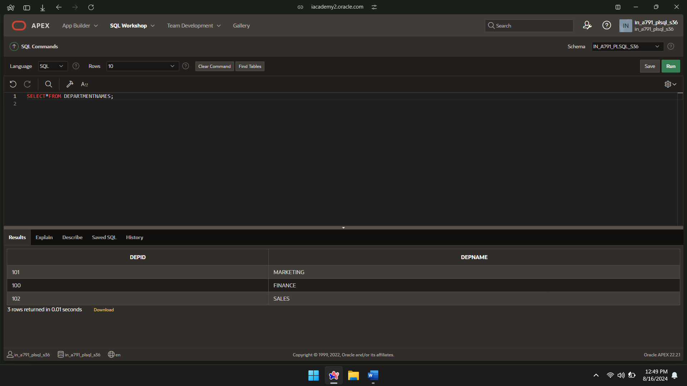

FUNCTION:

CREATE FUNCTION d_rows(p_table_name VARCHAR2)

RETURN NUMBER IS

BEGIN

EXECUTE IMMEDIATE 'DELETE FROM ' || p_table_name;

RETURN SQL%ROWCOUNT;

END;

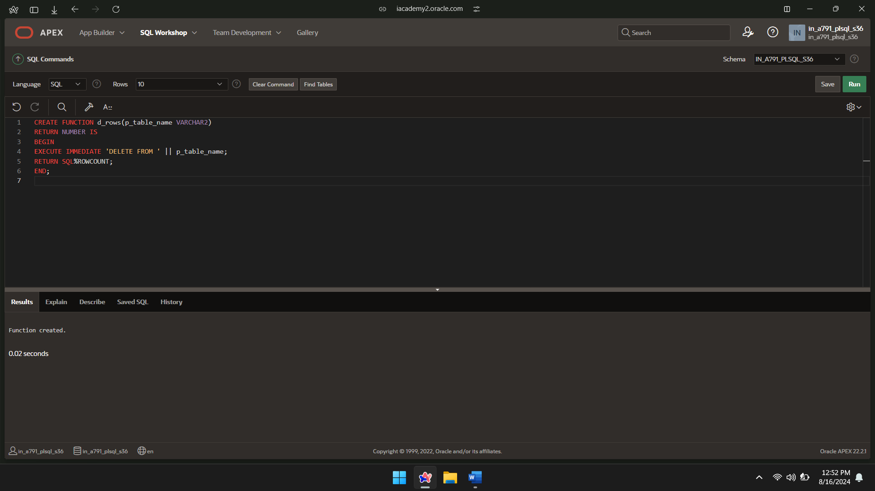

FUNCTION CALL:

DECLARE

del NUMBER;

BEGIN

del:= d_rows('DEPARTMENTNAMES');

DBMS_OUTPUT.PUT_LINE(del|| ' rows deleted.');

END;

